15.3 Carbon cycle
Name: ____________________ Class: ____________________ Due date:
Gas X is a waste gas from digestion in animals.
Gas Y is formed when gas X is burnt with a small amount of oxygen.
Gas Z is formed when gas X is burnt with an excess of oxygen.
What are X, Y and Z?
 | X | Y | Z
A | carbon dioxide | methane | carbon monoxide
B | carbon monoxide | methane | carbon dioxide
C | methane | carbon dioxide | carbon monoxide
D | methane | carbon monoxide | carbon dioxide

Which information about carbon dioxide and methane is correct?
 |  | carbon dioxide | methane
A | formed when vegetation decomposes | ✓ | ✗
B | greenhouse gas | ✓ | ✓
C | present in unpolluted air | ✗ | ✗
D | produced during respiration | ✗ | ✓
key $\begin{aligned}&✓=true \\ &✓=false\end{aligned}$

Which statement about methane is not correct?
A It is a liquid produced by distilling petroleum.
B It is produced as vegetation decomposes.
C It is produced by animals, such as cows.
D It is used as a fuel.

Many car exhaust systems contain a catalytic converter.
Which change does not occur in a catalytic converter?
A carbon dioxide $→$ carbon
B carbon monoxide $→$ carbon dioxide
C nitrogen oxides $→$ nitrogen
D unburnt hydrocarbons $→$ carbon dioxide and water

Catalytic converters are used to remove some gaseous pollutants from car exhaust fumes.
Which gas is removed from the fumes by oxidation?
A carbon dioxide B carbon monoxide C nitrogen D nitrogen oxide

Photosynthesis and respiration are important natural processes.
Which statement is correct?
A Carbon dioxide is formed by the reaction of glucose with water during photosynthesis. B Carbon dioxide is removed from the air by respiration.
C Glucose reacts with water to form oxygen during respiration.
D Photosynthesis produces glucose and oxygen.

Which process removes carbon dioxide from the atmosphere?
A combustion of fossil fuels
B decomposition of carbonates
C photosynthesis
D respiration

Oxides of nitrogen are formed in car engines and are a source of air pollution. To decrease this pollution, catalytic converters are fitted to car exhausts.
What happens to the oxides of nitrogen in the catalytic converter?
A combustion B cracking C oxidation D reduction

Catalytic converters in car exhausts change polluting gases into non- polluting gases.
Which statements about oxides of nitrogen and car engines are correct?
1 The nitrogen in oxides of nitrogen comes from compounds in petrol.
2 The oxygen in oxides of nitrogen comes from the air in the car engine.
3 Catalytic converters convert oxides of nitrogen into nitrogen and other gases.
A 1 and 2 B 2 and 3 C 2 only D 3 only

Some of the processes involved in the carbon cycle are shown.
1 glucose $+$ oxygen $→$ carbon dioxide $+$ water
2 carbon dioxide $+$ water $→$ glucose $+$ oxygen
3 methane $+$ oxygen $→$ carbon dioxide $+$ water
What are the names of these processes?
 | 1 | 2 | 3
A | combustion | respiration | photosynthesis
B | photosynthesis | combustion | respiration
C | respiration | combustion | photosynthesis
D | respiration | photosynthesis | combustion

Which row about the carbon cycle is correct?
 | process for removing carbon dioxide from the atmosphere | process for returning carbon dioxide to the atmosphere
A | photosynthesis | combustion of hydrocarbons
B | photosynthesis | cracking of hydrocarbons
C | respiration | combustion of hydrocarbons
D | respiration | cracking of hydrocarbons

The carbon cycle is shown.
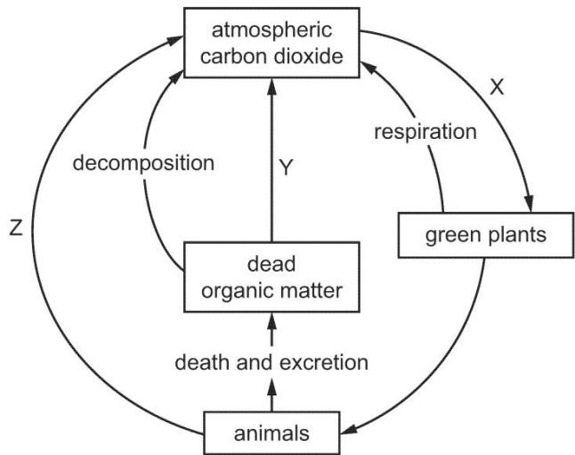
Which row describes processes X, Y and Z?
 | X | Y | Z
A | respiration | combustion | photosynthesis
B | respiration | photosynthesis | combustion
C | photosynthesis | combustion | respiration
D | photosynthesis | respiration | combustion

The following processes are part of the carbon cycle.
1 photosynthesis 2 combustion 3 respiration
Which processes decrease the amount of carbon dioxide in the atmosphere?
A 1 only B 1 and 2 only C 1 and 3 only D 2 and 3 only

Three processes in the carbon cycle are shown.
1 Methane reacts with oxygen producing carbon dioxide and water.
2 Carbon dioxide and water are absorbed and used by plants to make oxygen.
3 Oxygen is used by living things to release energy.
Which processes have taken place?
 | 1 | 2 | 3
A | combustion | photosynthesis | respiration
B | combustion | respiration | photosynthesis
C | photosynthesis | combustion | respiration
D | respiration | photosynthesis | combustion

Part of the carbon cycle is shown.
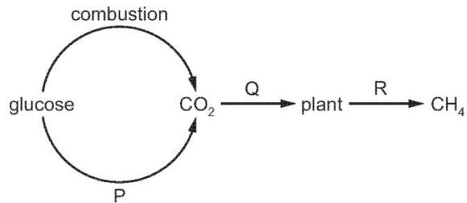
What are processes P, Q and R?
 | P | Q | R
A | decomposition | respiration | photosynthesis
B | respiration | photosynthesis | decomposition
C | respiration | decomposition | photosynthesis
D | photosynthesis | respiration | decomposition

The diagram represents an outline of the carbon cycle.
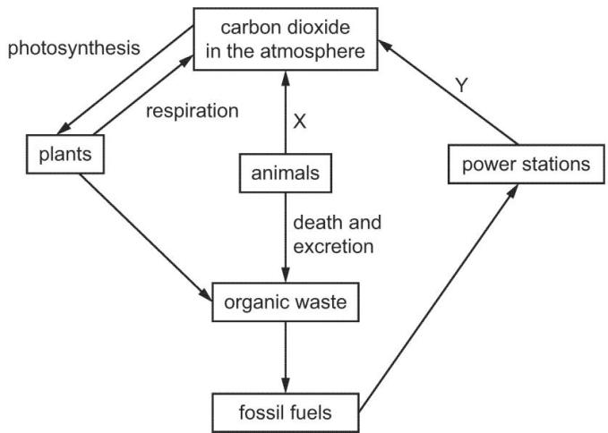
Which processes are X and Y?
 | X | Y
A | combustion | respiration
B | decomposition | respiration
C | photosynthesis | combustion
D | respiration | combustion

Catalytic converters reduce the pollution from motor vehicles.
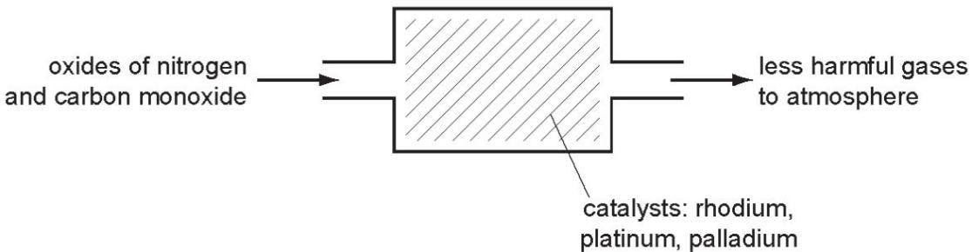
Describe how carbon monoxide and the oxides of nitrogen are formed in car engines.

Describe the reaction(s) inside the catalytic converter which change these pollutants into less harmful gases. Include at least one equation in your description.


Polluted air contains two oxides of carbon and two oxides of nitrogen. A major source of these pollutants is motor vehicles.
Describe how carbon dioxide and carbon monoxide are formed in motor vehicle engines.

State one adverse effect of each of these gases.

Clean, dry air contains a small amount of carbon dioxide.
The percentages of the other gases present in clean, dry air are shown in the table. Complete the table by inserting the names of these gases.
name of gas | percentage present
 | 78
 | 21
 | 1
[2]
Oxides of nitrogen are atmospheric pollutants which can cause acid rain.
Describe the formation of oxides of nitrogen and suggest how they can cause acid rain.

Methane contributes to the greenhouse effect.
State two sources of methane.
1.....................................................................................................................................
2.....................................................................................................................................
Combustion and respiration add carbon dioxide to the atmosphere.
Name one natural process which removes carbon dioxide from the atmosphere.
..................................................................................................................................[1]

Many cars have catalytic converters in their exhaust systems. In a catalytic converter, most of the CO and NO formed in a car engine is changed into less harmful products.
Identify these products and state the metal catalyst used. products catalyst
....................................................................................................................................
....................................................................................................................................
..................................................................................................................................[3]
CO is formed from the incomplete combustion of fossil fuels such as methane.
Write a chemical equation to show the incomplete combustion of methane.
..................................................................................................................................[2]
The ${CO}_{2}$ in air is part of the carbon cycle.
The scheme shows a simple representation of part of the carbon cycle.
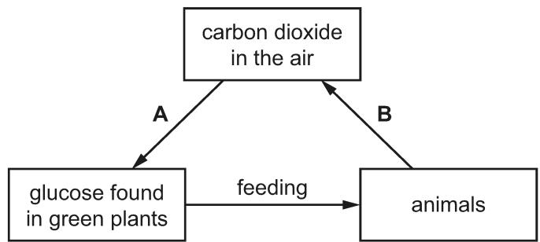
State the scientific terms for each of process A and process B.
A ....................................................................................................................................
B ....................................................................................................................................
Plants convert glucose into complex carbohydrates.

